

**GOVERNMENT ARTS SCIENCE COLLEGE – PAPPIREDDIPATTI**

**DEPARTMENT OF PHYSICS**

**NAAN MUTHALVAN ONLINE COURSE**

TEAM LEADER NAME : S.DHARSHINI

**PROJECT NAME**

Analysing housing price in metropolitan area

**FACULTY NAME: Dr .sakthivel**

**TEAM DETAILS** :

|  |  |  |
| --- | --- | --- |
| **NAME** | USERNAME | POSITION |
| DHARSHINI ,S | Per180c21ug180phy030 | TEAM LEADER |
| KIRUTHIKA .P | Per180c21ug180phy033 | MEMBER |
| BHAVANA .V | Per180c21ug180phy029 | MEMBER |
| GAYATHRI .k | Per180c21ug180phy031 | MEMBER |

TABLE CONTANT

1.INTRODUCTION

1. Overview

2. Purpose

2.PROBLEM DEFINITION & DESIGN THINKING

2.1 Empathy map

2.2 Ideation & Brainstorming

3.RESULT

4.ADVANTAGES & DISADVANTAGES

5.APPLICATIONS

6.CONCLUSION

7.FUTURE SCOPE

8.APPENDIX – A SOURCE CODE

**ANALYSING HOUSING PRICE METROPOLITON AREA**

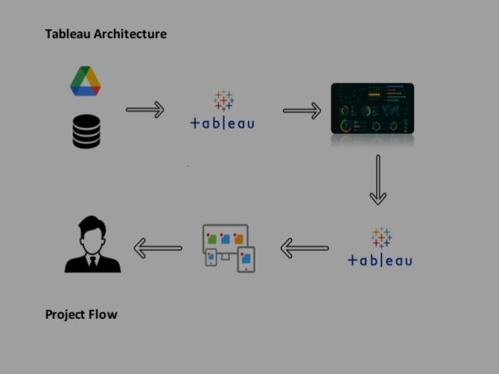**House price prediction in a metropolitan city in India is a valuable solution for Potential home buyers, real estate agents, and investors. By leveraging Historical sales data, property details, and location-specific information, a Predictive model can accurately estimate house prices. The model’s scalability, Real-time updates, user-friendly interface, and transparency ensure it meets The needs of stakeholders. Integration capability, data privacy, and costeffectiveness are also important considerations. By addressing these Requirements, the prediction model provides reliable insights, empowering Stakeholders to make informed decisions in the fast-paced real estate market.Tableau Architecture Project Flow**

**To accomplish this, we have to complete all the activities listed below,**

**● Define Problem / Problem Understanding**

**O Specify the business problem**

**O Business requirements**

**O Literature Survey**

**O Social or Business Impact.**

**● Data Collection & Extraction**

**O Collect the dataset**

**O Connect Dataset with Tableau**

**● Data Preparation**

**O Prepare the Data for Visualization**

**● Data Visualizations**

**O Number of Unique Visualizations**

**● Dashboard**

**O Responsive and Design of Dashboard**

**● Story**

**O Number of Scenes of Story**

**● Performance Testing**

**O Utilization of Data Filters**

**O Number of Visualizations/ Graphs**

**● Publishing**

**O Publishing Dashboard and Story on Tableau Public**

**● Project Demonstration & Documentation**

**O Record explanation Video for project end to end solution**

**O Project Documentation-Step by step project development**

**Milestone 1: Define Problem / Problem Understanding**

**Activity 1: Specify the business problem**

**The business problem at hand is the prediction of house prices in**

**A metropolitan city in India. The real estate market in such cities is**

**Complex and dynamic, making it challenging for potential home**

**Buyers, real estate agents, and investors to accurately estimate**

**Property values. By developing a predictive model using relevant**

**Datasets and features, stakeholders can gain insights into the**

**Factors influencing house prices and make informed decisions**

**Regarding property investments. The goal is to provide a reliable**

**And accurate prediction tool that assists users in navigating the**

**Competitive real estate market and maximizing their returns.**

**Activity 2: Business requirements**

**The business requirements for house price prediction in a**

**Metropolitan city in India include developing an accurate**

**Prediction model that can estimate property prices. The model**

**Should identify the key features impacting house prices and**

**Provide insights to aid decision-making. It should be scalable to**

**Handle a large volume of data and incorporate real-time updates**

**To reflect the latest market conditions. The solution should have a**

**User-friendly interface, ensure transparency and explain the ability**

**Of predictions, prioritize data privacy and security, and define**

**Performance metrics for evaluation. Integration capability and**

**Cost-effectiveness are also important considerations to deliver a**

**Valuable and efficient solution.**

**Activity 3: Literature Survey**

1. **Rosen, S. Hedonic Prices and Implicit Markets: Product**

**Differentiation in Pure Competition. J. Political Econ. 1974, 82, 34–**

**55. [Google Scholar] [CrossRef]**

1. **Can, A. Specification and estimation of hedonic housing price**

**Models. Reg. Sci. Urban Econ. 1992, 22, 453–474. [Google Scholar]**

**[CrossRef]**

1. **Kang, Y.; Zhang, F.; Peng, W.; Gao, S.; Rao, J.; Duarte, F.; Ratti, C.**
2. **Understanding house price appreciation using multi-source big geodata and machine learning. Land Use Policy 2021, 111, 104919. [Google Scholar] [CrossRef]**
3. **Yacim, J.A.; Boshoff, D.G.B. A Comparison of Bandwidth and Kernel Function Selection in Geographically Weighted Regression for House Valuation. Int. J. Technol. 2019, 10, 58. [Google Scholar] [CrossRef]**
4. **Tobler, W.R. A Computer Movie Simulating Urban Growth in the**

**Detroit Region. Econ. Geogr. 1970, 46, 234–240. [Google Scholar]**

**[CrossRef]**

**Activity 4: Social or Business Impact.Social Impact: Houses with best facilities in India. By analysing the**

**Number of bed rooms and Services provided , may somebody with The dilemma to buy or not buy his/her own houses based on price And best facilities.**

**Business Model/Impact: Can make this visualization application**

**Available for people, for more insights and ideas can ask for**

**Payment and also can give these insights to make the understand**

**And help in the sense of buying house.**

**Milestone 2: Data Collection**

**Data collection is the process of gathering and measuring information on**

**Variables of interest, in an established systematic fashion that enables one to**

**Answer stated research questions, test hypotheses, evaluate outcomes and**

**Generate insights from the data.**

**Activity 1: Downloading the dataset**

**Please use the link to download the dataset: Link**

**Activity 1.1: Understand the data**

**Data contains all the meta information regarding the columns described**

**In the CSV files**

**Activity 2: Connect Dataset with Tableau**

**Explanation video link:**

[**https://drive.google.com/file/d/11nyFJ7x2K6-GGWzsQ6S-i-nSqePkgyE/view?usp=sharing**](https://drive.google.com/file/d/11nyFJ7x2K6-GGWzsQ6S-i-nSqePkgyE/view?usp=sharing)

**Milestone 3: Data Preparation**

**Activity 1: Prepare the Data for Visualization**

**Preparing the data for visualization involves cleaning the data to remove**

**Irrelevant or missing data, transforming the data into a format that can**

**Be easily visualized, exploring the data to identify patterns and trends,**

**Filtering the data to focus on specific subsets of data, preparing the data**

**For visualization software, and ensuring the data is accurate and**

**Complete. This process helps to make the data easily understandable**

**And ready for creating visualizations to gain insights into performance**

**And efficiency.**

**Explanation video link 1:**

[**https://drive.google.com/drive/folders/15EVIuoprk6mAO55PHrXa5Cv**](https://drive.google.com/drive/folders/15EVIuoprk6mAO55PHrXa5Cv)

**zrQl2T4Br?usp=sharing**

**zrQl2T4Br?usp=sharing**

**Milestone 4: Data Visualization**

**Data visualization is the process of creating graphical representations of data**

**To help people understand and explore the information. The goal of data**

**Visualization is to make complex data sets more accessible, intuitive, and easier**

**To interpret. By using visual elements such as charts, graphs, and maps, data**

**Visualizations can help people quickly identify patterns, trends, and outliers in**

**The data.**

**Activity 1: Number of Unique Visualizations**

**The number of unique visualizations that can be created with a given**

**Dataset. Some common types of visualizations that can be used to**

**Analyze the performance and efficiency of Radisson Hotels include bar**

**Charts, line charts, heat maps, scatter plots, pie charts, Maps etc. These**

**Visualizations can be used to compare performance, track changes over**

**Time, show distribution, relationships between variables, breakdown of**

**Revenue and customer demographics, workload, resource allocation and**

**Location of hotels.**

**Activity 1.1: Latitude and Longitude based on Location**

**Explanation video link:**

[**https://drive.google.com/file/d/1KzYKZ6b7gnxaz_RodCq10aSRMNooUP0/view?usp=sharing**](https://drive.google.com/file/d/1KzYKZ6b7gnxaz_RodCq10aSRMNooUP0/view?usp=sharing)

**Activity 1.2: Number of houses based on area in sqf**

**Explanation video link:**

[**https://drive.google.com/file/d/1JoS0HSDQCJO35L0OfZTHNRW**](https://drive.google.com/file/d/1JoS0HSDQCJO35L0OfZTHNRW) **based on rainwater harvest pits**

**Activity 1.3: Houses price based on rainwater harvest pits**

**Explanation video link:**

[**https://drive.google.com/file/d/1ZnQMVbvW39IDx_42VCD8km**](https://drive.google.com/file/d/1ZnQMVbvW39IDx_42VCD8km)

**xaV4WlnStX/view?usp=sharing**

**Activity 1.4: Vastu-complains based on location**

**Explanation video link:**

[**https://drive.google.com/file/d/1r8fxUFigK2YVVlEnT8hzt36dxqh0**](https://drive.google.com/file/d/1r8fxUFigK2YVVlEnT8hzt36dxqh0)

**mhXW/view?usp=sharing**

**Activity 1.5: House price based on Number of Bedrooms**

**Explanation video link:**

[**https://drive.google.com/file/d/14HWIu7OXMPQWxMiMQiJHZ52t**](https://drive.google.com/file/d/14HWIu7OXMPQWxMiMQiJHZ52t)

**96gCIkqy/view?usp=sharing**

**Activity 1.6: Hospitals and schools near the Houses**

**Explanation video link:**

[**https://drive.google.com/drive/folders/1JOPfepPcK8IXNsZqtrEu**](https://drive.google.com/drive/folders/1JOPfepPcK8IXNsZqtrEu)

**9_WQ2bfed7JK**

**Activity 1.7: Maintains staff in houses prices**

**Explanation video link:**

[**https://drive.google.com/file/d/1kPFTBcXX3EeCDG2tGW4CtUSOcJT-OwE/view**](https://drive.google.com/file/d/1kPFTBcXX3EeCDG2tGW4CtUSOcJT-OwE/view)

**Activity 1.8 : House Price and Intercom**

[**https://drive.google.com/file/d/1TeDFaG3fGpm_5l3pKeZr3SKB5**](https://drive.google.com/file/d/1TeDFaG3fGpm_5l3pKeZr3SKB5)

**QkLwsMr/view?usp=sharing**

**Activity 1.9: All Services based on locations**

[**https://drive.google.com/file/d/1duCt2xHNtuhdrHFgbBrnjcpPhj**](https://drive.google.com/file/d/1duCt2xHNtuhdrHFgbBrnjcpPhj)

**vKddOW/view?usp=sharing**

**Milestone 5: Dashboard**

**A dashboard is a graphical user interface (GUI) that displays information and**

**Data in an organized, easy-to-read format. Dashboards are often used to**

**Provide real-time monitoring and analysis of data and are typically designed**

**For a specific purpose or use case. Dashboards can be used in a variety of**

**Settings, such as business, finance, manufacturing, healthcare, and many other**

**Industries. They can be used to track key performance indicators (KPIs),**

**Monitor performance metrics, and display data in the form of charts, graphs,**

**And tables.**

**Activity 1- Responsive and Design of Dashboard**

**Once you have created views on different sheets in Tableau, you can pull**

**Them into a dashboard.**

**Explanation video link:**

**Link**

**1:https://drive.google.com/file/d/1lox0XmjOwLwkI2Ny6YOHHAuwqWR**

**N2u27/view?usp=sharing**

**Link2 :**

[**https://drive.google.com/file/d/1r5CeOyKA2YhgOC8FYAhvtOPMM1HOA**](https://drive.google.com/file/d/1r5CeOyKA2YhgOC8FYAhvtOPMM1HOA)

**I4V/view?usp=sharing**

**Link**

**3:https://drive.google.com/file/d/1KnAe6YCqyCWZvu9ZCv8Eb7dBJm3e4**

**Vcx/view?usp=sharing**

**Link 4:https://drive.google.com/file/d/1k_JzPaBzsQjxYK-6W8s3w4mS2k3tMVNk/view?usp=sharing**

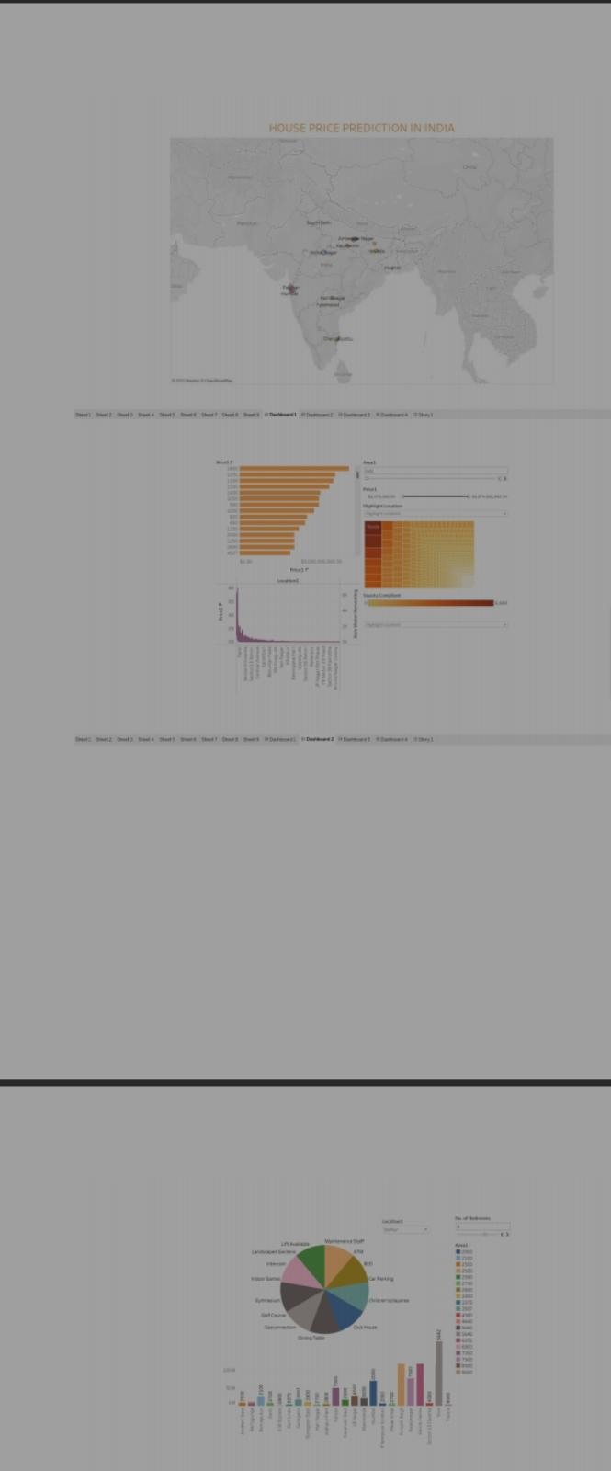

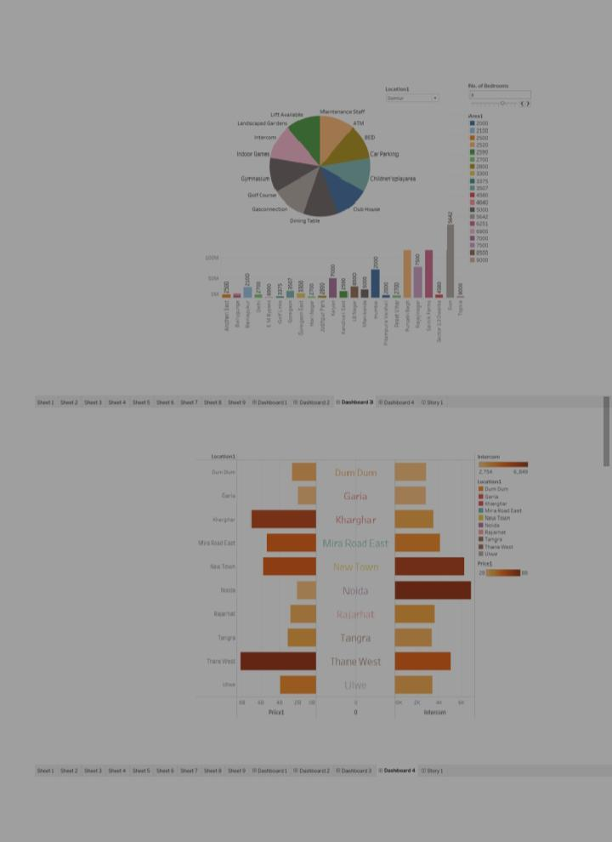

**Milestone 6: Story**

**A data story is a way of presenting data and analysis in a narrative format,**

**Intending to make the information more engaging and easier to understand. A**

**Data story typically includes a clear introduction that sets the stage and**

**Explains the context for the data, a body that presents the data and analysis**

**Logically and systematically, and a conclusion that summarizes the key findings**

**And highlights their implications. Data stories can be told using a variety of**

**Mediums, such as reports, presentations, interactive visualizations, and videos.**

**Activity 1- Number of Scenes of Story**

**The number of scenes in a storyboard for a data visualization**

**Analysis of the performance and efficiency of Radisson Hotels will**

**Depend on the complexity of the analysis and the specific insights**

**That are trying to be conveyed. A storyboard is a visual**

**Representation of the data analysis process and it breaks down the**

**Analysis into a series of steps or scenes.**

**Explanation video link:**

**https://drive.google.com/file/d/1OdCwcyXcullCni3423ObJaOOao7n-hA/view?usp=sharing**

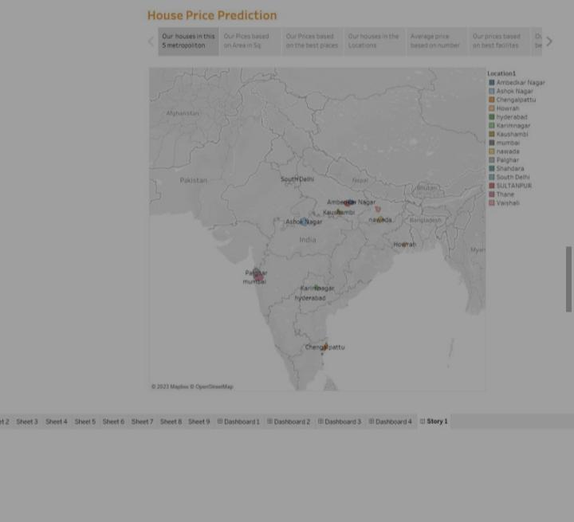

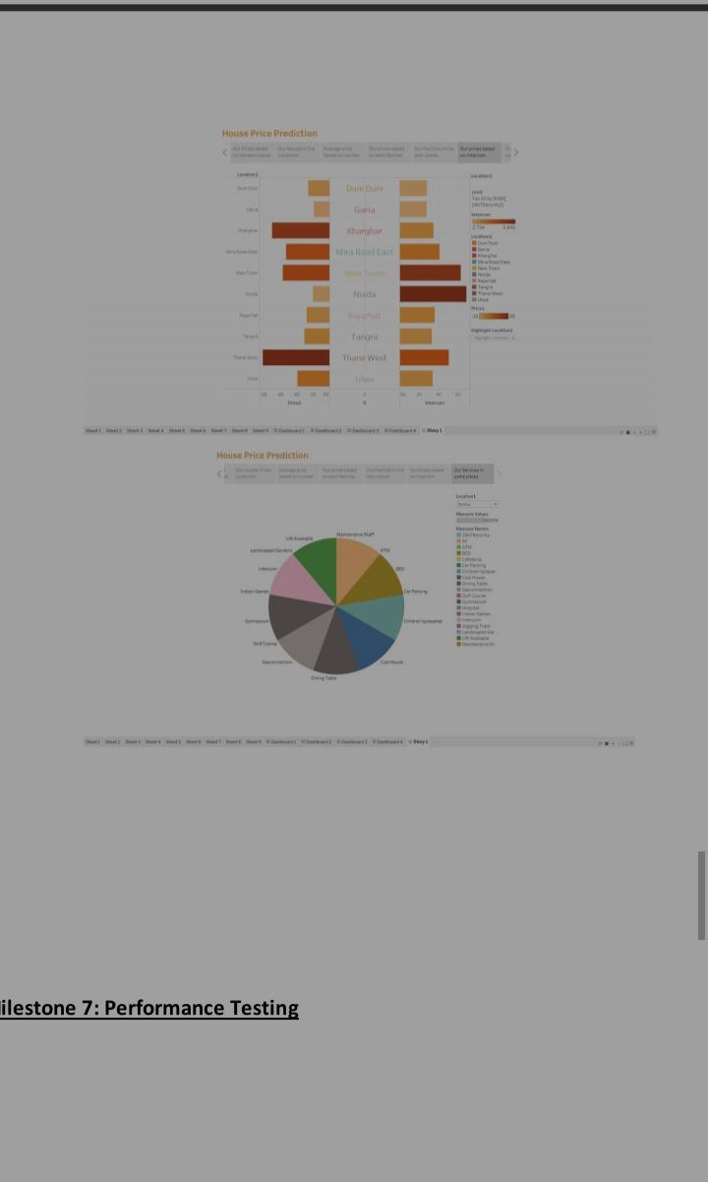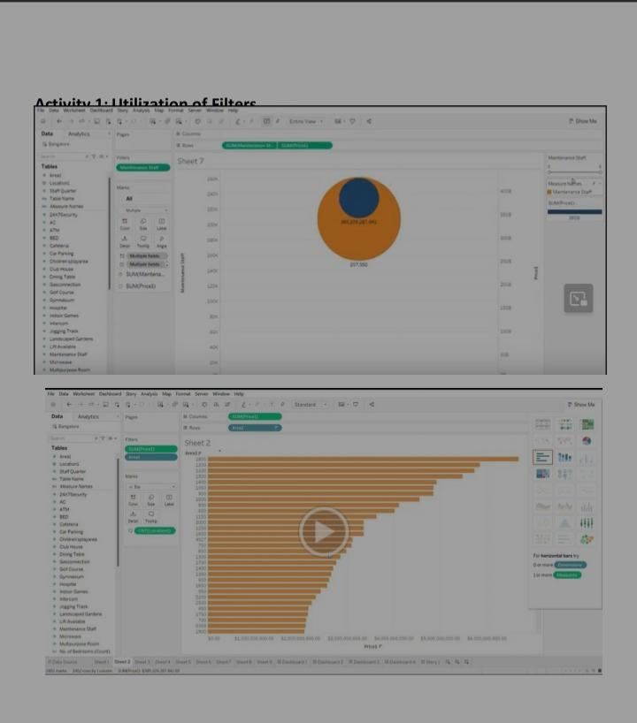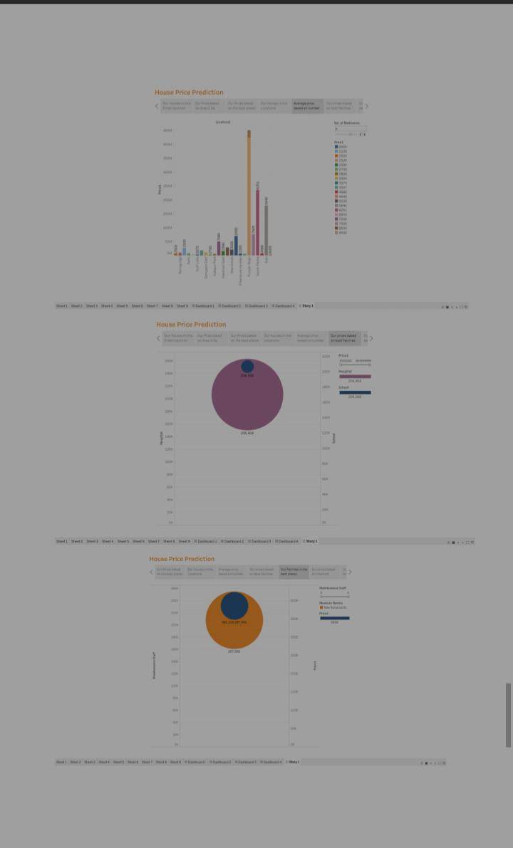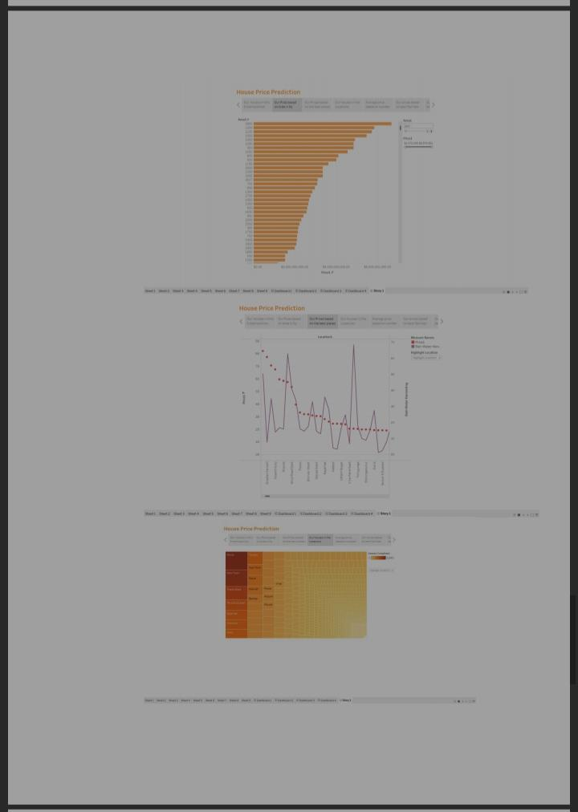

**Activity 2 : No of visualization / graph**

1. **Latitude and Longitude based on Location**
2. **Number of houses based on area in sqf**
3. **Houses price based on rainwater harvest pits**
4. **Vastu-complains based on location**
5. **House price based on Number of Bedrooms**
6. **Hospitals and schools near the Houses**
7. **Maintains staff in houses prices**
8. **House Price and Intercom**
9. **All Services based on locations**

**Milestone 8: Publishing**

**Publishing helps us to track and monitor key performance metrics and to Communicate results and progress. Help a publisher stay informed, make Better decisions, and communicate their performance to others.Publishing dashboard and reports to tableau public**

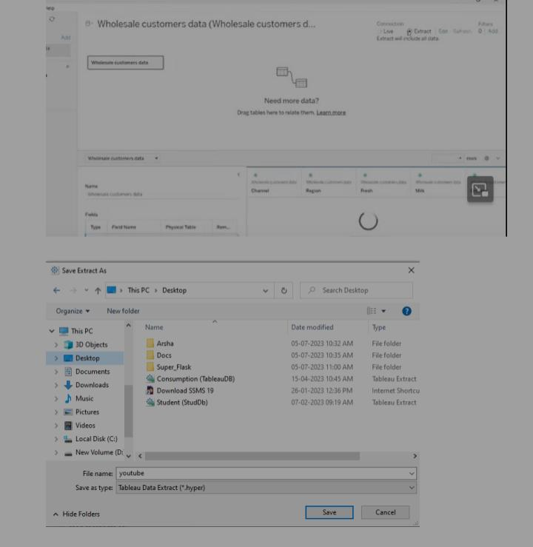**Step 1 Go to data Source and Select Extract so that .hyper extension files are Created and save it at your desktop. (please wait for pop up of file to save**

**Step 2: Go to Dashboard/story, click on the share button on the top ribbon**

**Step 2: Go to Dashboard/story, click on the share button on the top ribbon**

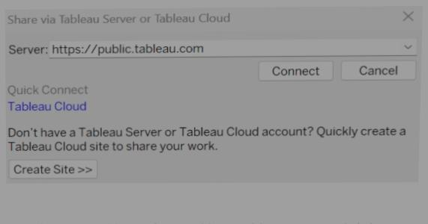

**Give the server address of your tableau public account and click on connect.**

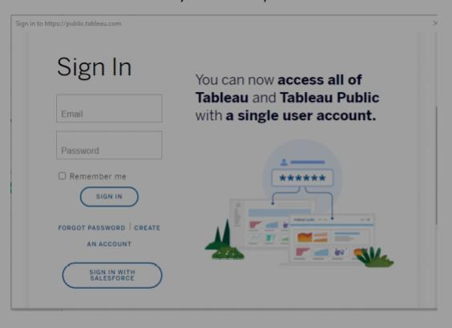

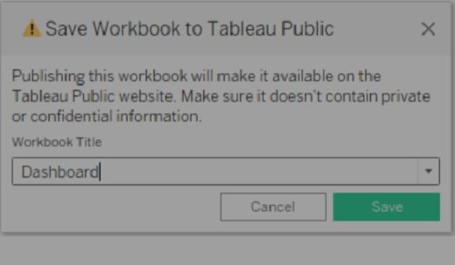

**Click on the “Save” button to start the publishing process. Tableau Desktop will Upload your workbook to Tableau Public.Once the upload is complete, a browser window will automatically open, Displaying your published workbook on Tableau Public. Review the workbook To ensure that everything appears as expected.So in Similar way we can also publish Story to tableau public.Once you login into your tableau public using the credentials, the particular Visualization will be published into the tableau public**

**Note: While publishing the visualization to the public, the respective sheet**

**Will get published when you click on the share option.**

**Milestone 9: Project Demonstration & Documentation**

**Below mentioned deliverables to be submitted along with other deliverables**

**Activity 1:- Record explanation Video for the project’s end-to-end**

**Solution.**

**Activity 2:- Project Documentation-Step by step project development**

**Procedure.**